These graphs provided are testing the LEDs with photoresistor and not upgraded TX or RX circuit. The graphs below show the Photoresistor Analog Values along the Y-axis and the number of values on the X-axis. The code is designed to test 200 values so once 200 values have been read then the light stops. The titles of graphs display what values were enter in for the RGB lights. The best values of RGB would be at the brightest light level.

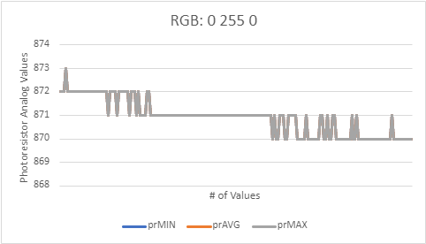

The graphs below show the Photoresistor Analog Values along the Y-axis and the number of values on the X-axis. The code is designed to test 200 values so once 200 values have been read then the light stops. The graphs below show the Bright Adafruit LED with low, half, and full brightness. The values given are more consistent with the high brightness.

These graphs provided are testing the Adafruit Bright LED with photodiode with the upgraded TX or RX circuit. The graphs below show the Photodiode Analog Values along the Y-axis and the number of values on the X-axis. I took the first 50 values from ADC and photodiode. Tested the room first then the LED brightness with 220-ohm resistance and then 10k resistance.

